Section 4.1: The Coordinate Plane

SOLs: None

Objectives: Students will be able to:
Locate points on the coordinate plane
Graph points on a coordinate plane

Vocabulary:
Coordinate plane – an x-y grid with axes as reference lines
Quadrant – the axes divide the coordinate plane into 4 regions or quadrants
Graph – is a plot of an ordered pair (x,y) on the coordinate plane

Key Concept:

Examples:
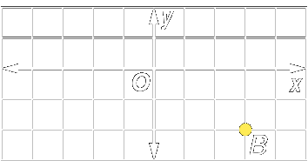
- Write the ordered pair for point B.

- Write ordered pairs for points A, B, C, and D.
Name the quadrant in which each point is located
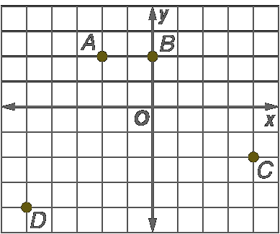

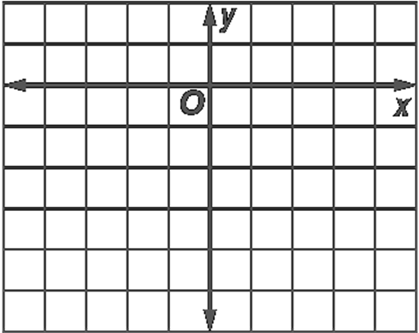
- Plot the following points on the coordinate plane
a. Plot A(3, 1)
b. Plot B(–2, 0)
c. Plot C(2, –5)

- Geography: Use the map in Example 4 on page 194 of your textbook to
a. Name the city at about (33°, 80°).
b. Estimate the latitude and longitude of Las Vegas.

Concept Summary:
The first number, or x-coordinate, of an ordered pair corresponds to the numbers on the x-axis
The second number, or y-coordinate, corresponds to the numbers on the y-axis

Homework: pg 195: 14-42 even
Section 4.2: Transformations on the Coordinate Plane

SOLs: None

Objectives: Students will be able to:
Transform figures by using reflections, translations, dilations, and rotations
Transform figures on a coordinate plane by using reflections, translations, dilations, and rotations

Vocabulary:
Transformation – movements of geometric figures
Preimage – position of the figure before the transformation
Image – position of the figure after the transformation
Reflection – figure flipped over a line
Translation – figure slid in any direction
Dilation – figure enlarged or reduced
Rotation – figure turned around a point

Key Concept:

Examples:

- Identify the transformation as a reflection, translation, dilation, or rotation.
a)  b) 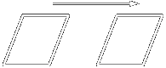
c) 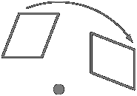 d) 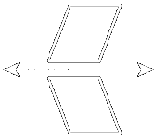

- A trapezoid has vertices W(–1, 4), X(4, 4), Y(4, 1) and Z(–3, 1). Trapezoid WXYZ is reflected over the y-axis. Find the coordinates of the vertices of the image.

- Triangle ABC has vertices A(–2, 1), B(2, 4), and C(1, 1). Find the coordinates of the vertices of the image if it is translated 3 units to the right and 5 units down.

- A trapezoid has vertices E(–1, 2), F(2, 1), G(2, –1), and H(–1, –2). Find the coordinates of the dilated trapezoid E′ F′ G′ H′ if the scale factor is 2.

- Triangle ABC has vertices A(1, –3), B(3, 1), and C(5, –2). Find the coordinates of the image of ΔABC after it is rotated 180° about the origin.

Concept Summary:
A reflection is a flip
A translation is a slide
A dilation is a reduction or an enlargement
A rotation is a turn

Homework: none
Section 4.3: Relations

SOLs: The student will
A.5 Create and use tabular, symbolic, graphical, verbal, and physical representations to analyze a given set of data for the existence of a pattern, determine the domain and range of relations, and identify the relations that are functions.

Objectives: Students will be able to:
Represent relations as sets of ordered pairs, tables, mappings, and graphs
Find the inverse of a relation

Vocabulary:
Domain – x-values in a relation
Range– y-values in a relation
Mapping – relates each element of the domain (x values) to an element in the range (y-values)
Inverse – switching the x and y-values in the ordered pairs

Key Concept:
Examples:

- Express the relation {(4, 3), (–2, –1), (–3, 2), (2, –4),
(0, –4)} as a table, a graph and a mapping.

- Opinion Polls: The table shows the percent of people satisfied with the way things were going in the U.S. at the time of the survey.
a) Determine the domain and range of the relation
b) Graph the data.
c) What conclusions might you make from the graph?
Year | 1992 | 1995 | 1998 | 2001
Percent Satisfied | 21 | 32 | 60 | 51

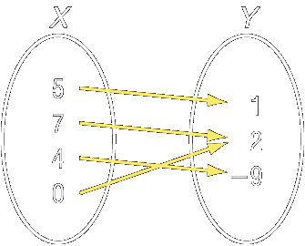
- Express the relation shown in the mapping as a set of ordered pairs. Then write the inverse of the relation.

Concept Summary:
A relation can be expressed as a set of ordered pairs, a table, a graph, or a mapping

Homework: pg 209; 18-36 even
Section 4.4: Equations as Relations

SOLs: The student will
A.5 Create and use tabular, symbolic, graphical, verbal, and physical representations to analyze a given set of data for the existence of a pattern, determine the domain and range of relations, and identify the relations that are functions.

Objectives: Students will be able to:
Use an equation to determine the range for a given equation
Graph the solution set for a given domain

Vocabulary:
Equation in two variables – equation that has two variable involved
Solution – an ordered pair that makes the equation a true statement
Independent variable – the domain variable (one that varies)
Dependent variable – the range variable (one that is dependent on the equation)

Key Concept:

Examples:

- Find the solution set for y = 7 + 3x given the replacement set {(–5, 0), (–3, –2), (2, 13), (4, 19)}.

- Solve d = 8 – c if the domain is {–2, 0, 3, 5, 8}.

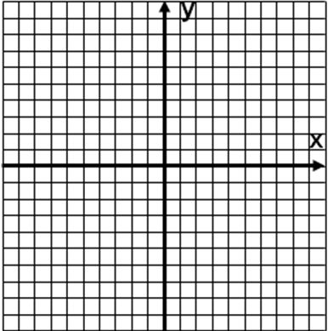
- Solve 9x + 3y = 15 if the domain is {0, 1, 2, 3}.
Graph the solution set.

- Travel: In 2002, 12 countries in Europe made the switch to a single currency, the euro. Suppose the exchange rate between U.S. dollars and euros is one dollar = 0.7216 euros. The equation E = 0.7216D can be used to convert U.S. dollars to euros. If a traveler is going to spend the following amounts per day while in Europe, find the equivalent U.S. dollars for the amounts given in euros (EUR) Graph the ordered pairs.

Hotel | 65 EUR
Food | 50 EUR
Transportation | 30 EUR
Gifts | 20 EUR

Concept Summary:
In an equation involving x and y, the set of x-values is the domain and the corresponding set of y-values is the range

Homework: pg 215; 14-38 even
Section 4.5: Graphing Linear Equations

SOLs: The student will
A.6 Select, justify, and apply an appropriate technique to graph linear functions and linear inequalities in two variables. Techniques will include slope-intercept, x- and y-intercepts, graphing by transformation, and the use of the graphing calculator.

Objectives: Students will be able to:
Determine whether an equation is linear
Graph linear equations

Vocabulary:
Linear equation – an equation of a line (when graphed)
Standard form – an equation of a line in the form Ax + By = C
x-intercept – x-coordinate where it crosses the x-axis (when y = 0)
y-intercept – y-coordinate where it crosses the y-axis (when x = 0)

Key Concept:

Examples:

- Determine whether the following is a linear equation. If so, write the equation in standard form.
  - 5x + 3y = z + 2
  - ¾x = y + 8
  - 3x – 6y = 27
  - ¼x = -7
- Graph ½y – x = 1

- Shiangtai walks his dog 2.5 miles around the lake every day.
Graph m = 2.5d, where m represents the number of miles walked and d represents the number of days walking.

- Determine the x-intercept and the y-intercept of 4x – y = 4. Then graph the equation.

Concept Summary:
Standard from: Ax + By = C, where A ≥ 0 and A and B are not both zero, and A, B, and C are integers whose greatest common factor is 1
To find the x-intercept, let y = 0.
To find the y-intercept, let x = 0.

Homework: pg 221; 16-36 even
Section 4.6: Functions

SOLs: The student will
A.5 Create and use tabular, symbolic, graphical, verbal, and physical representations to analyze a given set of data for the existence of a pattern, determine the domain and range of relations, and identify the relations that are functions.

Objectives: Students will be able to:
Determine whether a relation is a function
Find function values

Vocabulary:
Function – a relation where each domain value is paired with exactly one range value
Vertical line test– a vertical line touches a function only in one place
Function notation – f(x) read as f of x: range value = f(domain value)

Key Concept:

Examples:

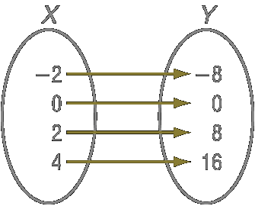
- Determine whether the relation is a function. Explain.
a. b.
c. {(–5, 2), (–2, 5), (0, 7), (0, 9)}
x | y
–7 | –12
–4 | –9
2 | –3
5 | 0

- Determine whether x = -2 is a function.

- Given the function, find its value at the given x.
a. If f(x) = 3x – 4, find f(4)
b. If f(x) = 3x – 4, find f(-5)
c. If f(x) = 3x – 4, find f(2 – x)
- Given the function, find its value at the given x.
a. If k(m) = m² - 4m + 5, find k(-3)
b. If k(m) = m² - 4m + 5, find k(6z)

Concept Summary:
A relation is a function if each element of the domain is paired with exactly one element of the range
Substitute values for x to determine f(x) for a specific value

Homework: pg 229-30: 18-42 even
Section 4.7: Arithmetic Sequences

SOLs: The student will
A.5 Create and use tabular, symbolic, graphical, verbal, and physical representations to analyze a given set of data for the existence of a pattern, determine the domain and range of relations, and identify the relations that are functions.

Objectives: Students will be able to:
Recognize arithmetic sequences
Extend and write formulas for arithmetic sequences

Vocabulary:
Sequence – set of numbers in a specific order
Terms – numbers in a sequence
Arithmetic sequence – a sequence where the difference between terms is constant
Common difference – difference between terms of an arithmetic sequence

Key Concept:

Examples:

- Determine whether the following sequence is arithmetic; justify your answer.
a. –15, –13, –11, –9, ...
b. $\frac{7}{8}, \frac{5}{8}, \frac{1}{8}, −\frac{5}{8}, \text{.}\text{.}\text{.}$

- Find the next three terms of the arithmetic sequence: –8, –11, –14, –17, ...

- Find the 9th term of the arithmetic sequence: 7, 11, 15, 19, ...

- Consider the arithmetic sequence –8, 1, 10, 19, ....
Write an equation for the nth term of the sequence.

Concept Summary:
An arithmetic sequence is a numerical pattern that increases or decreases at a constant rate or value called the common difference
To find the next term in an arithmetic sequence, add the common difference to the last term

Homework: none
Section 4.8: Writing Equations from Patterns

SOLs: The student will
A.5 Create and use tabular, symbolic, graphical, verbal, and physical representations to analyze a given set of data for the existence of a pattern, determine the domain and range of relations, and identify the relations that are functions.

Objectives: Students will be able to:
Look for a pattern
Write an equation given some of the solutions

Vocabulary:
Look for a pattern – problem solving technique
Inductive reasoning – deriving a general rule based on observation of many individual events
Deductive reasoning – use a general rule to help decide about a specific event

Key Concept:

Examples:

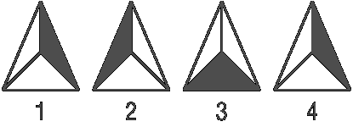
- Study the pattern to the right.
a. Draw the next three figures in the pattern
b. Draw the 17th triangle in the pattern.
- Find the next three terms in the sequence –3, –1, 3, 9, ....

- The table shows the number of miles driven for each hour of driving. Graph the data. What conclusion can you make about the relationship between the number of hours driving, h and the numbers of miles driven, m?

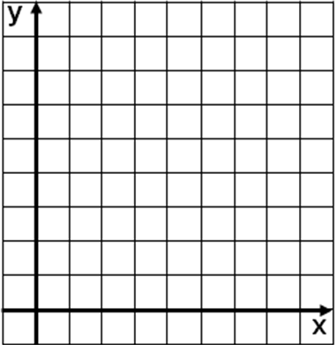
Hours | 1 | 2 | 3 | 4
Miles | 50 | 100 | 150 | 200

- Write an equation in function notation for the relation graphed below.

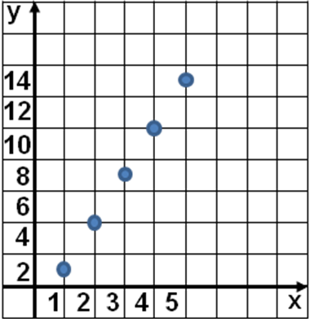

Concept Summary:
Look for a pattern in the data. If the relationship between the domain and the range is linear, then the relationship can be described by an equation

Homework: none

